Sibelius and the “Sound-sheet”:
Orchestral Innovations in the Early 20th Century
Thomas W. Patteson

Introduction

The musicological rehabilitation of Jean Sibelius, underway now for at least 20 years, may have reached a point of critical mass. It has been a formidable task: the contempt for Sibelius’ music expressed by critics such as Theodor Adorno and Virgil Thomson helped to establish the false image of composer as a traditionalist diehard, and thus made him into a convenient villain from the standpoint of the historical narratives under construction in the first half of the twentieth century. But that is not all: as Tim Howell notes, Sibelius’ own advocates, such as Olin Downes and Bengt de Törne, latched onto his perceived conservatism and championed him as a classically rooted bulwark against a trendy, sensationalistic modernism represented primarily by Schoenberg and Stravinsky. The project of rehabilitation has therefore involved some degree of defending Sibelius against his devotees.
Moreover, the attempt to re-evaluate the composer's legacy has sometimes ensnarled its advocates into the same unhelpful polemics that characterized Sibelius’ reception in the first place. Howell rightfully suggests that notions of what is “progressive” in twentieth-century music are slippery and historically fluid, but his argument for Sibelius’ progressiveness invokes a distinction between “those who seek to reinterpret the past” and “those who try to overturn it.” We cannot really know whom Howell has in mind with this barb, but it seems unlikely that this polarity is any more fruitful than previous shibboleths designed to valorize one group at the expense of another.
The history of musical modernism is typically dominated by considerations of pitch organization: the rejection of common-practice tonality around 1910 is seen as a nodal moment which filters out modern (atonal) from traditional (tonal) composers. This model has two major problems. First, it poses tonality and atonality as a rather straightforward binary, rather than as idealized extremes on a vast continuum of possibility. It fails to address the crucial matter that Sibelius’ tonality is not Schubert’s, and that Stravinsky’s atonality is far removed from Schoenberg’s. In short, it is a duality whose only obvious benefit is its pedagogical convenience. More fundamentally, though, the historiographical fixation on pitch structures has led to the neglect of other parameters and other ways of thinking about twentieth-century music. This is certainly not the place to enter into a discussion on the comparative perceptual importance of the various dimensions of musical sound, and it is incontestable that pitch organization is among the most salient and basic characteristics of music for most listeners. The fact that pitch lends itself least problematically to graphical representation also helps to explain its primacy in explanations of music-historical developments. But it is precisely because other parameters are so subtle and so difficult to grasp analytically that it is worthwhile to listen to music—especially twentieth-century music, where other dimensions take on new compositional importance—in terms of timbre, texture, and form. As Howell argues, a pitch-oriented analytical approach can obscure what is actually most interesting and modern in some music, including Sibelius’:
Understanding the relevant underlying patterns of pitch-class relationships will explain something of an overall level of unity within a given piece and this is undoubtedly reassuring for both listener and analyst alike. But it does not fully account for the elements of diversity, for the effect of music that seems, at one and the same time, to be both static and dynamic, slow- and fast-moving, repetitive yet varied: in short, music that involves contradictory perceptions of time.

Behind the sound-sheet: Hearing Sibelius’ orchestral textures

In the discussions surrounding some of the most striking passages in Sibelius’ orchestral writing, a term has emerged whose frequent recurrence demands close consideration. This is the idea of the “sound-sheet” and its variants. The expression seems to occupy an awkward middle ground between technical terminology and journalistic description: it suggests something at once aurally palpable and analytically dodgy. The genealogy of the term is a matter of speculation, but some derivation from the German Klangfläche seems likely. This, however, is of only little help, as Klangfläche shares with “sound-sheet” the status of a non-formalized descriptor. Jeffrey Kallberg has traced the term back to a 1970 essay by Monika Lichtenfeld, who sees the emergence of Klangflächenkomposition in the orchestral textures of Richard Wagner. Lichtenfeld frames the issue in terms of the “emergence of the formal function of tone-color”: as timbre and orchestration become increasingly independent compositional factors in the late nineteenth century, composers increasingly turn their attention from motivic construction to coloristic effects. For Lichtenfeld, the movement of music in time is bound up with thematic development; by negating this, Klangflächenkomposition thus moves music away from its own dimension of time toward “Farbigkeit und Flächigkeit”—that is, toward the realm of timeless spatiality. A nascent fixation on tone-color and orchestral effect gives rise to a tendency toward athematicism, which is in turn negates conventional, post-Beethovenian expectations of formal development and engenders a static conception of musical time.
The possibility of a relation (whether influence or simply affinity) between Lichtenfeld’s Klangfläche and Sibelius' "sound-sheets" is strengthened by significant conceptual overlap between the two terms. There is a striking affinity between Lichtenfeld’s categories of 1970 and the language of several prominent Sibelius scholars writing in the last 15 years. Sound-sheets in Sibelius are described primarily in terms of three musical parameters:
- PITCH: “Harmonic stasis”; “harmonic near-immobility”; “overlapping ostinato texture”; “suspension of harmonic direction”; “erosion of the thematic surface”

- ORCHESTRATION: “Elevation of texture as a primary structural parameter”; “distinctly unconventional spacing and sonority by the orchestral habits of the time”; “startling, almost electronic quality”

- TIME: “Smooth, almost imperceptible changes”; “strangely distended timing”; “Actively moving timbre surfaces […] undergirded by a more fundamental, deep-current slow motion”

Isolating these parameters is the easy part; the challenge of making sense of Sibelius’ distinctive approach to orchestration is to grasp how the different musical dimensions interact and mutually determine each other. Lichtenberg was quick to recognize this analytical difficulty: “The term ‘sound-sheet’ is thus difficult to pin down with a definition, as it refers to no single sonic quality or precise compositional circumstances. Rather, it denotes a multiplicity of musical characteristics that are normally kept separate in analysis, and attempts to describe their coherence and their relation to one another.” The problem posed by the analytical untangling of these textures can be seen as a concentrated case of the difficulty of musical analysis all told: although the differentiation of musical parameters is a practical necessity, it is crucial to keep in mind that the various dimensions of musical sound never actually function in isolation, but always in reciprocal feedback. Analysts must sacrifice some of their claims to clinical precision if it is to be able to grasp parametrical interaction in its full perceptual richness. Also, it should be made clear that the purpose here is not so much to establish once and for all what a sound-sheet is, but to begin to unpack the dense bundle of musical qualities contained in the term.
One of the most strikingly unique of Sibelius’ orchestral techniques is the construction of swirling, complex textures resulting from the overlay of numerous repeating scalar “loops”. The loops themselves may be more or less tonally directed, but the total compositional fabric to which they contribute is marked by an intensely centripetal sense of stasis. This is achieved through a careful rhythmic displacement, so that each loop’s inherent directionality is counteracted by other loops sounding at different phases of the same scalar course. It is likely the seething, hypnotic effect of such textures that has elicited claims of “proto-minimalism” in Sibelius’ music. One example of such a passage occurs in the first movement of Sibelius’ Symphony No. 1 (1899-1900), at rehearsal mark P. (All measure numbers given hereafter are in reference to P, as no measure numbers appear in the score.) The passage extends over 34 measures, ending at rehearsal mark S. It is situated at the end of a lengthy development section, and leads into the clearest thematic statement of the entire movement. The texture can be reduced to two essential components: a descending chromatic figure in the woodwinds, and an ascending chromatic run in the celli and double bass. This latter figure is relatively straightforward: the double bass climbs in eight-notes from E₁ to a (with some variation in the terminal pitch), while the celli, echoing the bass in staggered entries, ascend likewise from their lowest note C to a high point of a. The entries of the two instruments are placed to create varying degrees of overlap in the scalar pattern, and when the voices move simultaneously they are almost always in parallel octaves.
Though it involves the same underlying compositional principle, the woodwind writing in this passage is a bit more complex. Like the entries of the low strings, those of the woodwinds are irregularly staggered. But whereas the bass and celli move in constant eighth-notes, the descending woodwind figures begin with a long note (varying in length from 3 to 21 quarter beats) followed by half-note which begins the chromatic fall. After the first two notes, the figure moves in regular quarter notes. Further complicating the texture, the quarter-note section of the woodwinds’ chromatic runs appears in parallel thirds, and, beginning in measure 15, in parallel octaves and tenths. The pitch levels of the successive woodwind entries at first outline an ascending diminished triad: disregarding the flute, which enters late, the first entry of each instrument is on F# (mm. 1, 2), the second is on A (mm. 4, 5, 7), and the third is on C (mm. 9, 10, 11). After this buildup of tension the pitch level of the entries stabilizes at A, where it remains until moving to C for the last few entries in measures 28-32.
Remarkable as this passage is, its function within the movement is that of a rather conventional keying up of developmental intensity leading into the moment of recapitulation. The appearance of the main theme in the violins and viola in measure 21 is broken off at the end, heightening the drama. It shows up again in measure 29, this time a third higher, but again its proper unfolding is frustrated. Finally, after rehearsal S, it sounds at its “proper” pitch level, and the turgid chromaticism of the preceding passage gives way to a lusty, almost Viennese accompaniment.



A more elaborate example of Sibelius’ technique of splicing scalar passages is found in his 1908 symphonic poem Nightride and Sunrise (four measures between rehearsal 33). Here the sound-sheet texture serves as a backdrop for the main thematic material of the first half of the piece, a weighty but laconic minor-key motive stated by the violins and violas and echoed by the piccolo and bass clarinet. Similar to the passage in the first symphony, the texture here is essentially two-part: two lines for divisi celli versus flutes, oboes, clarinets, and bassoons, each instrument in pairs. The celli repeat the same two-measure loop of triplet 32nd-notes outlining a G minor scale, with the two groups offset such that one plays the first measure while the other plays the second, and vice-versa. Meanwhile, each of the paired woodwinds forms a meandering, fully diatonic two-voice canon, repeating the same scalar loop no fewer than seven times. The phase relations of the two voices of each pair seem designed to create abundant contrary motion and cover the widest pitch-space possible: the flute line, for example, extends from a low note of a to a high note of b2, and the two voices are aligned such that the peak in one corresponds with the trough in the other. The effect of this carefully structured timbral web is a paradoxical motion within stasis, a churning sound surface which is at once extremely active and ultimately immobile.



Even where surface activity is minimized and the orchestral texture approaches a condition of actual stasis, Sibelius often manipulates the musical fabric to create a subtle sense of motion. A frequently-cited example of this is found in the late tone poem Tapiola (1926), beginning at rehearsal C. While the woodwinds play a variation of the primary theme, four groups of violins combine to project the major second E-F# over the three octaves of the instrument’s range The four groups are paired so that two trade off playing in the upper and middle octaves, while two alternate the middle and lower octaves. Thus, although at any given moment there is the same registral dispersion—one group in the upper and lower octaves and two in the middle—the scoring lends the passage a shimmering, incandescent quality belied by the plain appearance of the notation. Gradually the lower strings, including contrabass, are added to the texture, which ultimately spans a full six octaves. As Julian Anderson notes, this passage is among the most boldly original in all of Sibelius, and it foreshadows the orchestral experiments of the later twentieth century.
Another example of the creative scoring of a static harmony occurs in the opening measures of The Swan of Tuonela (from the Lemmenkäinen Suite of 1895-97). Here a simple A minor sonority is voiced by staggered entries of muted strings, first in the contrabasses and cellos, then successively an octave higher in the violas, second violins, and first violins. Each group enters pianissimo, swells in volume, then drops out, creating a gradual brightening of timbre even as the harmony remains unchanged. The sound is uncannily similar to the “filter sweep” that players electronic synthesizers would mine to no end in the 1960’s and 70’s.


In contrast to Sibelius’ “loop splicing” technique, where a high degree of local surface activity coincides with a global nondirectionality, in these two examples stasis predominates over motion. Still, the effect of Sibelius’ orchestration is to imbue this stasis with a sense of process or unfolding.
Two of Sibelius’ last compositions provide examples of some of his most extreme orchestral writing. The first is what Daniel Grimley calls the “storm sequence” near the end of Tapiola (mm. 513-576). Here the tremolo strings, divided into eight groups with only minimal doubling among them, engage in a dissonant polyphonic web, building up to a frenzy which is tamed only by the forceful tutti intervention in measure 569. Tomi Mäkelä has described this passage as “micropolyphonic,” and the anachronism seems warranted, since orchestral writing of such contrapuntal density (and violence) is often thought to have originated in the music of post-World War II composers such as Ligeti, Penderecki, and Xenakis. A similar idea is taken to much greater lengths in the Prelude of Sibelius’ incidental music for The Tempest (1926), which begins with a lengthy storm scene depicting the opening events of Shakespeare’s play. The vertiginous chromaticism and incessantly lurching triplet figures of this piece create a modern apotheosis of musical mimesis comparable to Haydn’s famous “Representation of Chaos” from The Creation. Julian Anderson draws a distinction between the “strangely distended timing” of such passages and the more static sound-sheet effect:
During all such textures, any clear sense of harmonic direction is virtually suspended in a manner not found in any other music prior to 1960…. Whilst not static (unlike the ‘sound sheets’), these passages convey to the listener a keen sense of time being stretched out as the transformations take on a life of their own, heedless of traditional symphonic rhetoric.

These moments from Sibelius’ late works are undoubtedly among his most emphatically modern and forward-looking gestures. They are rightfully seen as prescient of many compositional developments which took place over a quarter century after Sibelius’ last finished musical utterances. Having been rescued from charges of historical obsolescence, Sibelius’ music is now subject to the opposite, and admittedly less pernicious, misapprehension: that of being seen as a wayward prophet ahead of his time. “Sibelius as proto-minimalist/proto-spectralist/proto-neo-tonalist” threatens to become the new commonplace. These connections can and ought to be made, but not at the expense of the effort to understand Sibelius’ music in its own historical context. This is so not only for the sake of Sibelius’ legacy, but also, and more importantly, for our understanding of the music of the first quarter of the twentieth century. To hear Sibelius’ music in this context is to reconsider our understanding of this period as a whole, and to begin to move toward a more nuanced sense of history. The second half of this paper thus makes a few provisional steps in that direction.

Ravel: The sound-sheet in miniature

A little-known but remarkable example of a chamber-scale sound-sheet is found in Maurice Ravel’s song “Soupir” from his Trois poèmes de Stéphane Mallarmé for singer, two flutes, two clarinets, string quartet, and piano (1913). The piece begins with an immediately striking texture scored for two violins, viola, and cello. A combination of natural and artificial string harmonics and six-against-eight hemiola obscures the already ambiguous harmony, which could be described either as an E minor 11 chord or as superimposed E minor and D major triads. More remarkable than this texture itself is the function it serves in the composition, extending over the first 16 of the song’s 37 measures, and lasting a full two minutes—half of the total duration—in performance. The pattern established in the first quarter beat remains unchanged throughout. If this string texture itself can be described as extremely static, however, the first half of the song builds an intense dramatic arc around it. This is achieved though a subtle combination of means: soft piano chords, doubling the harmony of the strings, enter in measure 8 and expand outward in both directions from the central axis of d-e. The flute, entering on the last beat of measure 9, ascends slowly through an E pentatonic scale. Meanwhile, the pensive, circular meanderings of the vocal part reach their high note of F# just as the piano reaches its nadir on an open fifth (E-B) which underlines the root of the background harmony, and the flute reaches its apex an octave above the voice.

Example 1: Opening string texture in Ravel’s “Soupir”

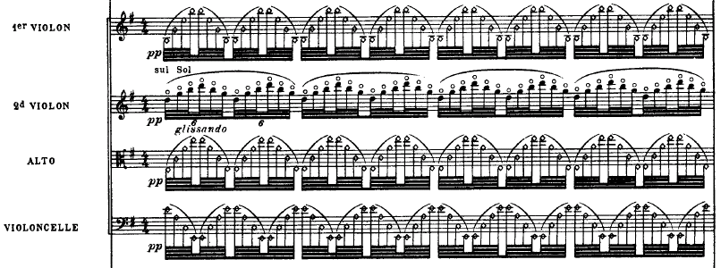


As an aside, this texture bears a notable resemblance to a sound-sheet passage in Sibelius early tone poem En saga (1892, revised 1902). As in “Soupir”, this texture appears first by itself and is then overshadowed by the entrance of a “foreground” melodic voice (mm. 5-24 after rehearsal A). The projected harmony is quite a bit simpler—essentially an F# minor triad with an added sixth—but the aural effect created by rapid arpeggios in contrary motion is similar to that of Ravel’s song.


Robert Gronquist hears the opening texture of this song “as if without time, or with time halted,” keying in on the effect of stasis often identified as a primary characteristic of the sound-sheet. But this sense of timelessness goes deeper than the hypnotic repetition of a pattern. Not only does the opening string figure of “Soupir” exhibit the “motion within stasis” often heard in Sibelius’ orchestral writing; the other voices, too, move within the relatively constrained space of a largely pentatonic pitch collection. Jonathan Harvey has written insightfully about the sense of “timeless suspension” often associated with the use of the pentatonicism in Western music since the 19th century. As Harvey notes, the symmetrical structure of the common pentatonic scale can vitiate the sense of a single pitch center, instead suggesting each tone as a possible point of repose; the scale thereby becomes “a musical expression of suspension in space.” Ravel overlays a pentatonically-inflected tonal stasis with a subtle, processual change of texture. The climax in measure 31 of “Soupir” is remarkable for having nothing to do with harmonic or melodic resolution: there is no change of chord, and the peak note in the voice and flute is preceded not by the leading tone but by a major third below. The incredible intensity of this moment is a function of registral expansion and textural accumulation, and the effect, though undeniably climactic, is far removed from the release of tension associated with cadential closure.

Schoenberg: Klangfarbenmelodie and Klangfläche

The music of Sibelius and Schoenberg is seldom spoken of in the same breath. Though the two men were close contemporaries (Sibelius was born nine years before Schoenberg and outlived him by six), and in spite of strong affinities in their personalities (such as stoic individualism and feelings of weighty music-historical burdens), their music is generally held to occupy different universes. The reasons for this, some indeed well-grounded, cannot be covered here, but at least one aspect of Schoenberg’s musical and theoretical work presents an intriguing point of contact with Sibelius’ orchestral techniques. This is his much-discussed notion of Klangfarbenmelodie (“tone-color melody”), first presented in the Harmonielehre of 1911, where Schoenberg speculates whether it would be possible to create progressions of tone-color “whose relations with one another work with a kind of logic entirely equivalent to that logic which satisfies us in the melody of pitches.” Just what Schoenberg meant by this term is one of the interminable controversies of twentieth-century music: Carl Dahlhaus has argued against a strict interpretation of Klangfarbenmelodie, according to which it denotes a single pitch given successively different tone-colors. Instead, Dahlhaus views Klangfarbenmelodie as the attempt to foreground the logic of timbral variation alongside traditional melodic variation of pitch level. This reading makes more sense than that which it replaced, but seems to render Schoenberg’s idea rather innocuous. If Klangfarbenmelodie is simply an expression for a heightened sensitivity to timbre, it gives voice to a tendency already in abundant evidence by 1911 But Alfred Cramer has recently put forth a radical new interpretation which, if valid, would help put Schoenberg’s timbral innovations into dialogue with Sibelius’ orchestral language. Cramer argues convincingly that Schoenberg, in accordance with prevalent thinking in acoustics around the turn of the twentieth century, envisioned Klangfarbe not as an isolated parameter of tone-color, but rather as a master concept which encapsulates sound in all its sonorous dimensions. Schoenberg writes:
The distinction between tone color and pitch, as it is usually expressed, I cannot accept without reservations. I think the tone becomes perceptible by virtue of tone color, of which one dimension is pitch. Tone color is, thus, the main topic, pitch a subdivision. Pitch is nothing else but tone color measured in one direction.

As Cramer puts it, Schoenberg imagines “a higher level of perception in which pitch variation will be heard not in terms of height but instead in terms of color.” The evidence for this interpretation of Klangfarbenmelodie is convincing on its face, but Cramer marshals an additional argument that goes further in demolishing the conventional understanding of the term. In a 1951 attempt to clarify the concept, Schoenberg referred to several passages from his early works which he sees as examples of Klangfarbenmelodie. Two of these, a fleeting passage from Pelleas und Melisande and the opening of the famous fourth movement of his String Quartet, Op. 10, suffice to show that what Schoenberg had in mind had little to do with a logically ordered series of tone-colors. In Schoenberg’s words, the components of Klangfarbenmelodie are “never merely individual tones of different instruments at different times, but rather combinations of moving voices.”

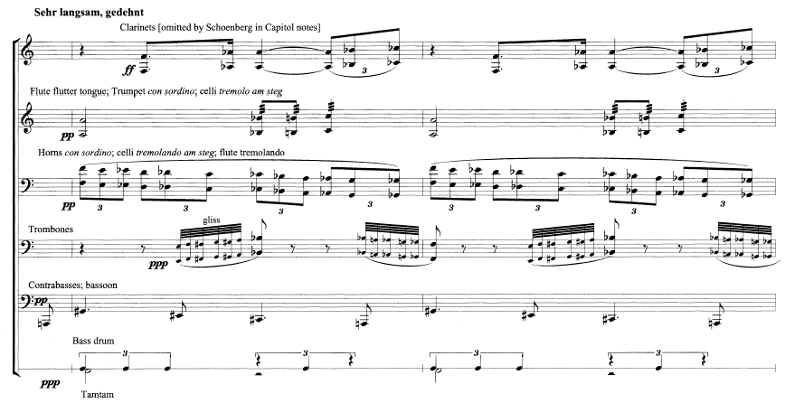

Example 2. Schoenberg, Pelleas und Melisande, mm. 6-7 after rehearsal 30. (Reproduced from Cramer, p. 5.)

These two passages, distant as they are from Sibelius’ music, make audible what Klangfläche and Klangfarbenmelodie might have in common. Both of Schoenberg’s examples exhibit the deft interweaving of brief, quasi-motivic fragments, a technique which plays a prominent role in Sibelius’ construction of his characteristic sound-sheet textures. The fact that Schoenberg writes in a freely atonal idiom, while Sibelius employs primarily diatonic tonality, does nothing to undermine this affinity. Indeed, twelve-tone composition, lacking the strong gravitational pull afforded by tonal centers, is perhaps inherently inclined to effects of stasis. This tendency toward atemporality was a major target of Adorno’s critique in Philosophy of Modern Music:
Twelve-tone technique contradicts dynamics. The technique neutralizes the dynamic impulse of the work from one sound to another; thus it does not permit any dynamic impulse of the totality to emerge. It devalues the concepts of melos and theme, and thus eliminates the actually dynamic-formal categories of motivic development, thematic development and transition.

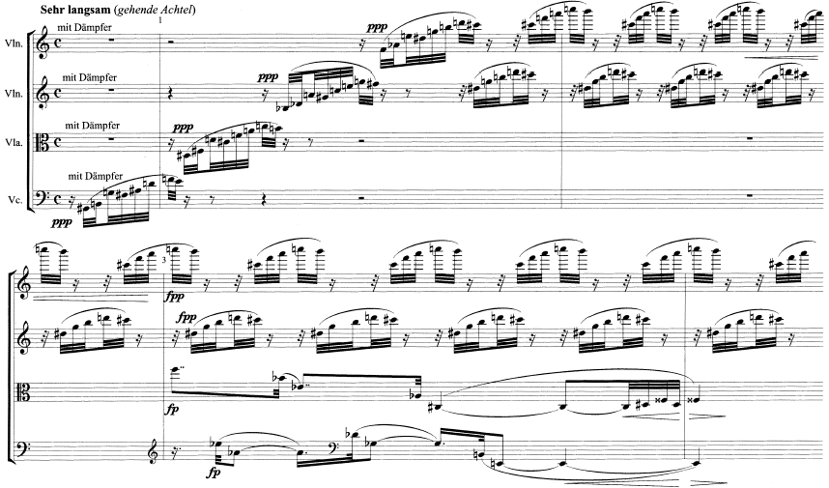
Example 3. Schoenberg, String Quartet No. 2, Op. 10, fourth movement, mm. 1-3. (Reproduced from Cramer, p. 6.)

Of course, one should be careful of conflating the free atonality of the period around 1910 with the twelve-tone system introduced by Schoenberg in the early 1920’s. In addition, there is certainly a distinction to be made between music in which the sense of directionality is simply neutralized, as in Adorno’s depiction, and that in which the “arrow of time” is turned back on itself. With this in mind, let us turn briefly to the retroactive locus classicus of Klangfarbenmelodie, the third of Schoenberg’s Five Pieces for Orchestra, Op. 16 (1909). How does this piece appear in light of Sibelius’ roughly contemporaneous orchestral experiments? The performance direction affixed to the score emphasizes the importance of the shifting orchestral timbres, and advises “avoiding accentuation of entering instruments, so that only the difference in color becomes audible.” The note also states, tellingly, that “there are no motives in this piece which have to be brought to the fore.” Indeed, the only recognizable motivic features of the piece are the wheezing, syncopated textural rhythm established in the opening measures and a tiny, two-note appoggiatura figure marked, strangely, as Hauptstimme, which first occurs in the bass clarinet in measure 227 (the measure numbers in the score are continuous through all five pieces). In spite of this dearth of surface-level thematic content, the piece evinces a rather clear formal contour delineated primarily by means of textural expansion and contraction. The opening texture of woodwinds, brass, and low strings gives way, after a fermata in measure 231, to a momentarily thinned scoring of horn, trombone, harp, and violin. Quickly the texture expands to encompass the full range of the orchestra in measure 237; all the while, the languorous syncopated rhythm presented at the beginning of the piece churns away, providing the foundation for the sudden interjections of the Hauptstimme motive. The orchestral texture remains quite full until the end of the piece, but from measure 245 on there emerges another kind of textural intensification, namely the marked increase in event frequency in all voices. This process reaches its peak in measure 249, followed by a sudden falling away of the thick orchestral wall and a moment of near silence. A strangely conspicuous birdcall in the piccolos inaugurates the final formal breath of the piece, which again takes up the wheezy, hurdy-gurdy orchestral drone.
Although this piece exhibits the “harmonic near-immobility” and the “elevation of texture as a primary structural parameter” which have been cited as defining features of Sibelius’ sound-sheet textures, it also differs from this model in a number of important ways. Most obviously, Schoenberg’s fluctuating fields of orchestral density constitute the entirety of Farben; the sound-sheet is the piece. Comparable textures in Sibelius, as we have seen, are always integrated into an overarching form, in which they can serve a number of different structural functions, such as introductory, developmental, and climactic. (Then again, if Op. 16 is considered as a whole, as it would most often be heard, the peculiarity of Farben would be mitigated by its more conventional neighboring pieces.) Another difference is that Schoenberg builds his texture primarily out of single held notes, whereas Sibelius’ basic components tend to resemble ostinati figures or arpeggios. Farben thus lacks the paradoxical quality of motion within stasis that characterizes much of Sibelius’ music; it could accordingly be seen as something of a middle ground between the archetypical Sibelian sound-sheet and the extreme static immobility of a single held sonority, as for example the prelude to Wagner’s Das Rheingold.

Conclusion

The dominant tendency of viewing twenieth-century music in terms of innovation within a single dimension of musical structure has led to inevitable valorizations of some composers and demonizations of others. Without necessarily abandoning innovation or novelty as a historiographical criterion, a less parochial vantage point can be attained by taking into account all dimensions of musical form. Not only does this help to enfranchise some composers who have been traditionally slighted by scholars of music, but it also illuminates otherwise obscured aesthetic commonalities, such as that I have argued for between the orchestral thinking of Sibelius and Schoenberg. The paramount task is to see how all composers of the time were attempting to strike a balance between continuity and change, tradition and modernity.

“Sibelius and the ‘Sound-Sheet’: Orchestral Innovations in the Early 20th Century” (2007) by Thomas W. Patteson is licensed under a Creative Commons Attribution-NonCommercial-NoDerivs 3.0 Unported License.

Tim Howell, “Sibelius the Progressive,” in Sibelius Studies, ed. Timothy L. Jackson and Veijo Murtomäki (Cambridge and New York: Cambridge University Press, 2001), 35.
Howell, 40.
Email correspondence with Prof. Cristoph von Blumröder, 13 March 2007.
Monika Lichtenfeld, “Zur Technik der Klanflächenkomposition bei Wagner,” in Das Drama Richard Wagners als musikalisches Kunstwerk, ed. Carl Dahlhaus (Regensburg: Gustav Bosse Verlag, 1970), 161-67.
The notion of the “sound-sheet is closely related to another common trope in Sibelius scholarship, that of “proto-minimalism”. The fact that these two terms occur in conjunction with many of the same works is evidence of their conceptual common ground. The precise nature of their relation will have to be dealt with elsewhere.
Daniel M. Grimley, “The tone poems: genre, landscape and structural process,” in The Cambridge Companion to Sibelius, ed. Daniel M. Grimley (Cambridge: Cambridge University Press, 2004), 101, 105.
James Hepokoski, Sibelius: Symphony No. 5 (Cambridge: Cambridge University Press, 1993), 20.
Grimley, 105.
Julian Anderson, “Sibelius and Contemporary Music,” in The Cambridge Companion to Sibelius, 198.
Lorenz Luyken, quoted in Tomi Mäkelä, Poesie in der Luft. Jean Sibelius: Studien zu Leben und Werk (Wiesbaden: Breitkopf & Härtel, 2007), 283.
Grimley, 101.
Anderson, 197.
Anderson, 198.
Grimley, 114.
Anderson, 198.
Hepokoski, 28
Lichtenfeld, 161. (“Der Terminus Klangfläche ist insofern definitorisch so schwer dingfest zu machen, als er keine einzelne Toneigenschaft und keinen präzisen kompositorischen Sachverhalt meint, vielmehr eine Mehrzahl von musikalischen Merkmalen, die in der Regel analytisch getrennt voneinander rangieren, gerade in ihrem Zusammenhang, in ihrem Verhältnis zueinander umschreibt.”)
Anderson, 197-98.
Grimley, 115.
Mäkelä, 285.
Anderson, 198.
Robert Gronquist, “Ravel's ‘Trois Poèmes de Stéphane Mallarmé’,” The Musical Quarterly 64, no. 4 (1978), 513. Theo Hirsbrunner explicitly refers to this texture (in the piano reduction, no less) as a Klangfläche: see “Zu Debussys und Ravels Mallarmé-Vertonungen,” Archiv für Musikwissenschaft, 35, no. 2 (1978): 81-103.
Jonathan Harvey, In Quest of Spirit: Thoughts on Music (Berkeley: University of California Press, 1999), 71-73.
Arnold Schoenberg, Theory of Harmony, trans. Roy E. Carter (London: Faber Music, 1978), 421-22, quoted in Orchestration: An Anthology of Writings, ed. Paul Mathews (New York: Routledge, 2006), 155.
Carl Dahlhaus, Schoenberg and the New Music, trans. Derreck Puffett and Alfred Clayton (Cambridge: Cambridge University Press, 1987), 141-43.
Alfred Cramer, “Schoenberg’s Klangfarbenmelodie: A Principle of Early Atonal Harmony,” Music Theory Spectrum 24, no. 1 (2002), 1-34.
Schoenberg, quoted in Mathews, 155.
Cramer, 8.
Cramer, 4.
Theodor W. Adorno, Philosophy of Modern Music, trans. Anne G. Mitchell and Wesley V. Bloomster (London: Sheed & Ward, 1973), 99.
Arnold Schoenberg, Five Pieces for Orchestra, Opus 16. New Version (New York: C. F. Peters, 1952), 31.

